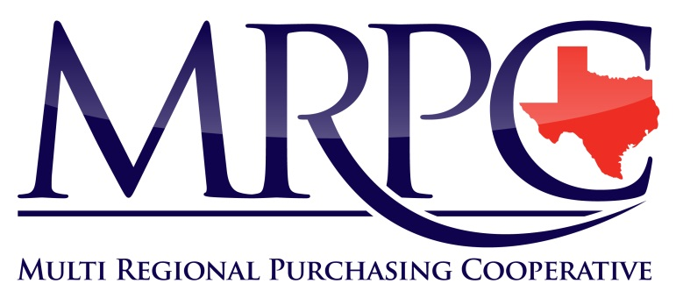

The Multi Regional Purchasing Cooperative (MRPC) actually began as a cooperative at Region 9 Education Service Center (ESC) to help member districts with paper purchases. Back in the mid to early 70s, the cooperative was expanded to become a combined purchasing cooperative which included the purchasing of maintenance and operational supplies. During this time, Baker Duncan and Empire Paper were the major suppliers for the co-op.

Originally, suppliers would deliver to one central location at Region 9 ESC, then the schools would come on the designated day to pick up the items that had been ordered. Because the districts were picking up items that were ordered in bulk, they would have to come in trucks with trailers attached to them to accommodate their loads.

In 1994, Region 14 ESC joined with Region 9 ESC which started the Multi Regional Purchasing Cooperative. Region 15 ESC became a part of the cooperative in 1995 and Region 11 ESC later joined in 1997. By joining their purchasing power, the Regional Service Centers enabled their school districts to purchase items from four major categories at discounted prices. As participation in the Cooperative grew among the Service Centers, so did the request for items to purchase. The Combined Purchasing allowed districts to order items from the following categories: Furniture, Janitorial Supplies, Paper and School Supplies.

Currently, there are 470 items on the combined purchasing list, which is a one-time purchase for the year. As purchasing laws changed, the schools expressed a need to have a list of vendors that they would be able to purchase from throughout the school year. In 1996, the Instructional Catalog and Technology Catalog components were added to the cooperative. This allows vendors to bid their entire product line (catalog) with proper documentation to meet purchasing laws, giving member districts the opportunity to purchase from them during the effective period.

Today, the cooperative is entering a new era of complete on-line bidding and purchasing. This online system will make procuring goods more competitive while being more efficient, and also provide us with additional opportunities to serve our districts in the future.

